1. Shopping Cart Page low fidelity wireframe

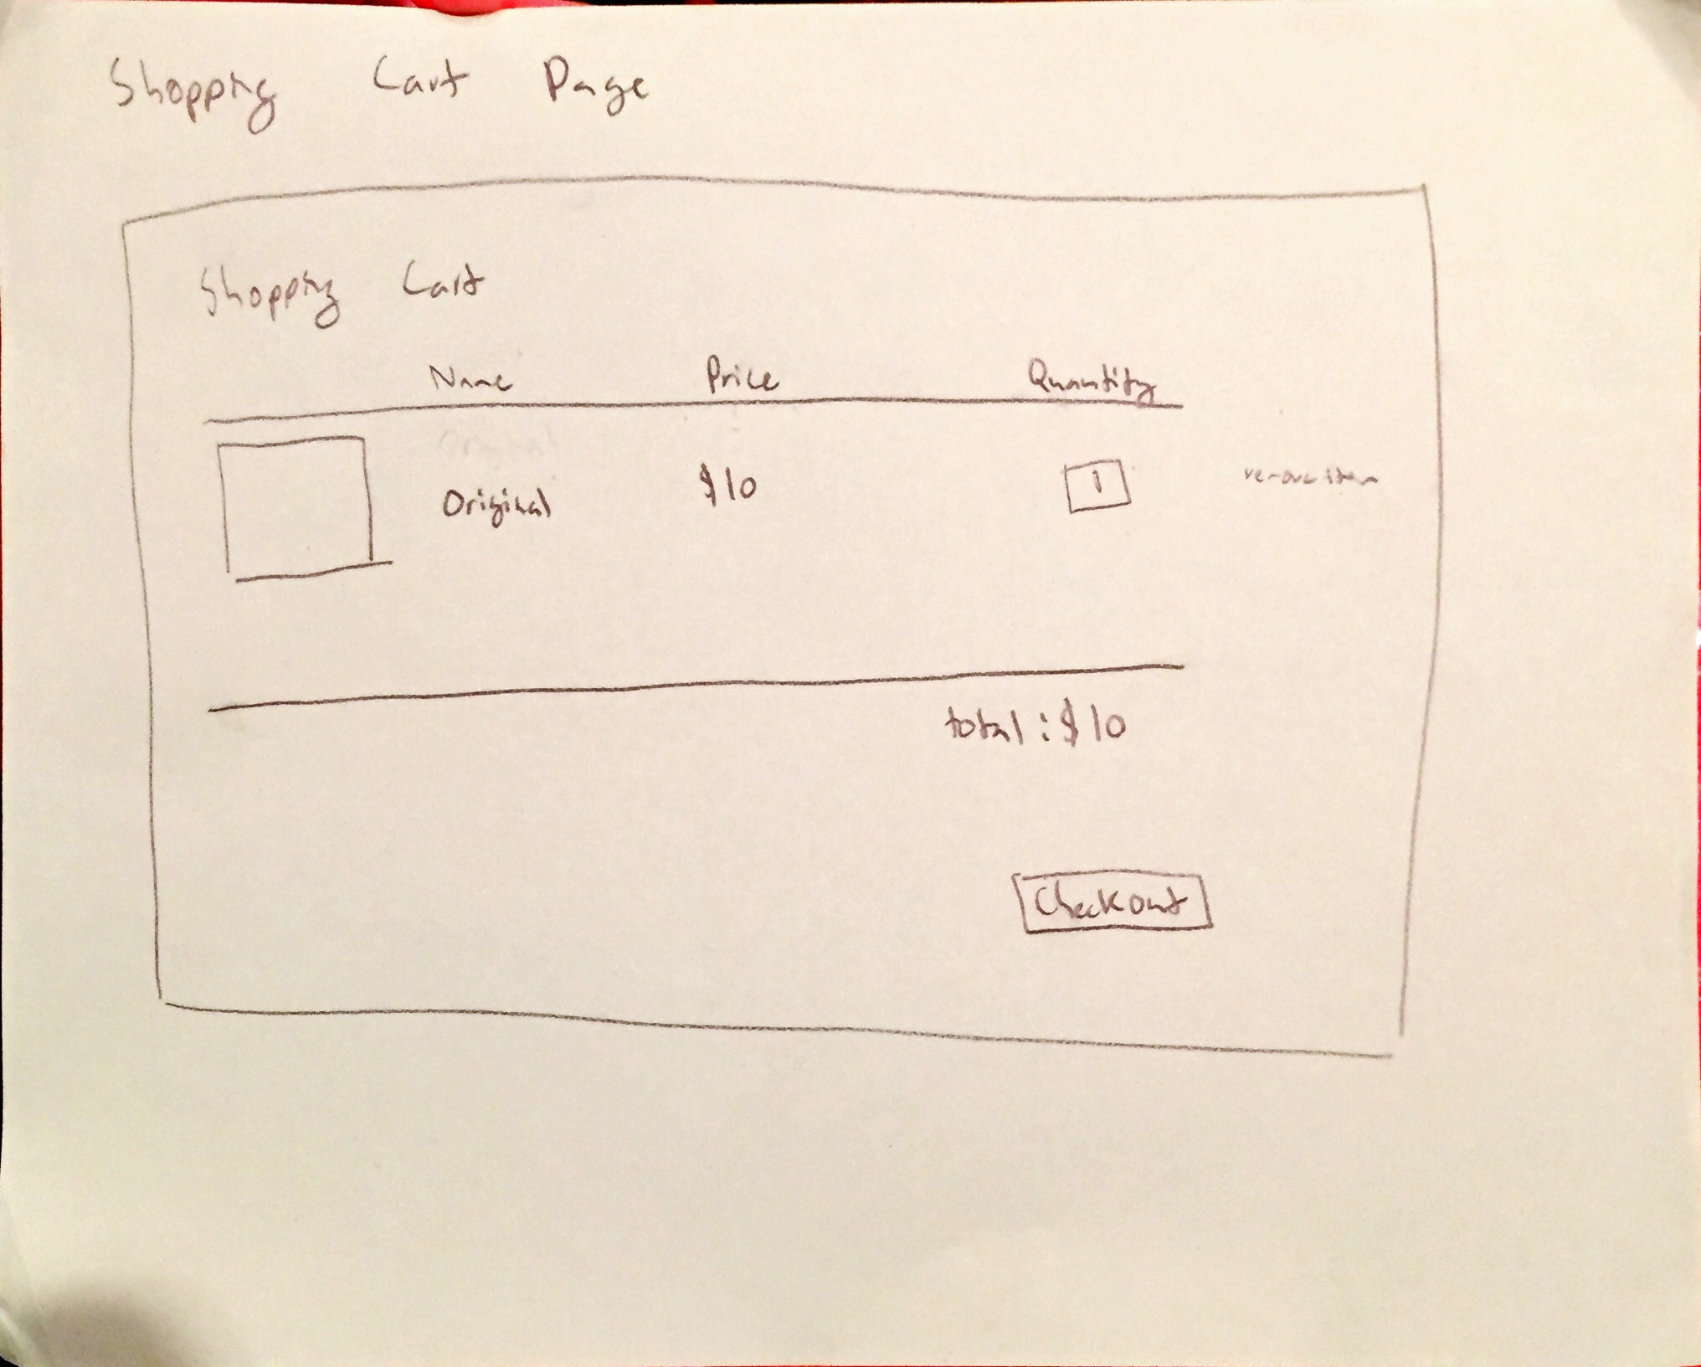

1. Shopping Cart Page high fidelity wireframe

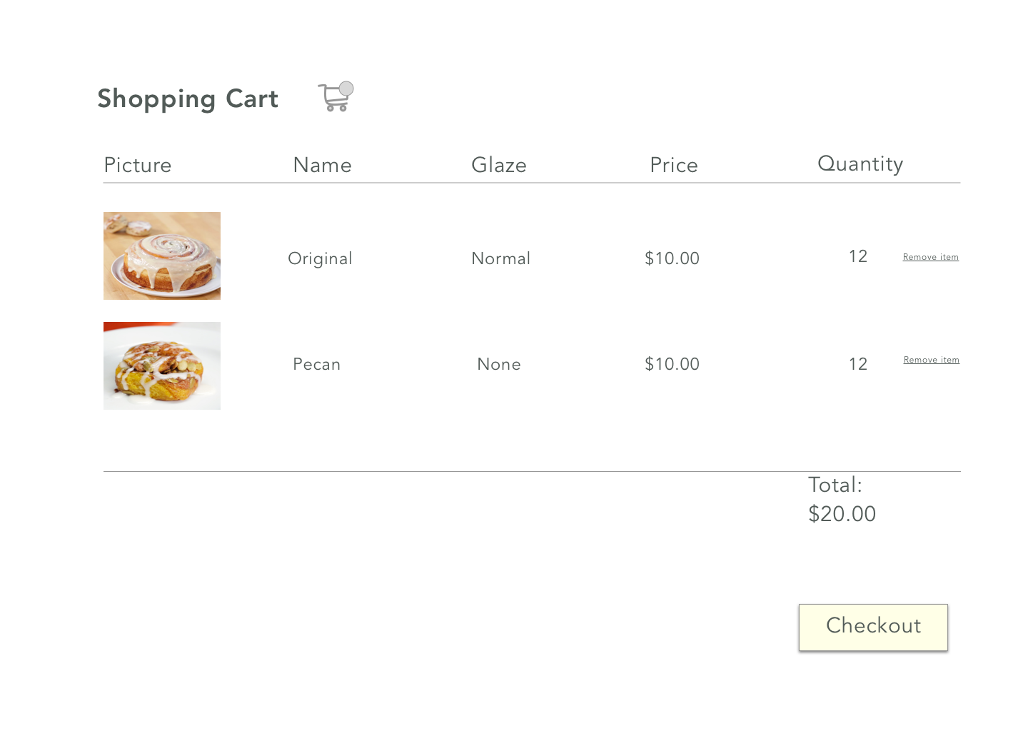

1. Reflection:
   1. What challenges or bugs did you encounter?
      1. In this assignment, I had trouble with many different things. The hardest part of the assignment was implementing a remove button that would remove the items from my cart. I had stored my cart items in an object that would keep all of the information about the product in an array of cart objects. I struggled with figuring out how to structure my code so I could remove the cart object on the interface and also remove it from local storage. Another bug that I had encountered was one that involved my product detail page. For some reason whenever I added something to my cart after refreshing the page the localStorage would be overwritten with a new array of rolls.
   2. How did you overcome such challenges?
      1. For my second problem, I used many console.log statements to print out what my code was doing. This helped me to find out the problem with my code, which turned out to be a global variable that was messing everything up. For my first problem, I really struggled with figuring out how to delete the item from local storage. Eventually, with the help of Francesca, we created a way to store the index of the object in a div and retrieve it for later when we deleted the item.